# Executive Summary

By building premium, energy-efficient apartments at reasonable costs, “UnlockHomes” addresses Australia's housing affordability issue. They focus on low-income individuals and use cutting-edge techniques like prefabrication to cut expenses and building timeframes. “UnlockHomes” gives government cooperation top priority when looking for project prospects and funding to guarantee long-term success. In order to customize initiatives to communities' needs, they also actively engage with them. Despite obstacles like well-established rivals and a shortage of available land, “UnlockHomes” is confident that their emphasis on value through affordability and cutting-edge building methods will place them in a position to play a significant role in resolving Australia's housing issue.

**UnlockHomes:**

**A Strategic Approach to**

**Affordable Housing in Australia**



Table of Contents

Executive Summary 1

Introduction 4

Analysis of Case Study 5

Social consequences like 5

Economic consequences like 6

5*5 RISK MATRIX 7

Competition 8

STAKEHOLDER MATRIX 10

VRIO ANALYSIS 12

Resource-Based View 13

Core Competency Analysis 14

PESTLE Analysis 15

Customer Persona 16

Demographics 16

Gantt Chart 17

Reference List 18

# Introduction

Australia is experiencing acute housing problem. Many residents are facing financial hardship and unstable living situations as a result of rising rental costs and a lack of affordable housing. This puts social stability and the general well-being of the country at risk because it hits hardest young families, low-income earners, and important jobs.

This essay aims to provide a roadmap for “UnlockHomes” to contribute to solving the Australian housing crisis. We will explore how our company, through innovative construction practices and a collaborative approach with the government, can offer sustainable and affordable housing solutions for low-income earners.

We recognize the urgency of the housing crisis and are committed to building high-quality, energy-efficient apartments and townhouses at attainable prices.

We will explore new construction sites closer to urban centres, expanding access to essential services and amenities while optimizing land use within the existing metropolitan area.

To save costs and build faster while upholding high standards of quality, we will apply creative and economical building methods, utilizing prefabrication and modular construction.

We will actively seek opportunities to work together on government housing projects and make use of any subsidies or incentives that are available for projects including affordable housing. Then further more We'll talk to people in the neighbourhoods where we're building to make sure our projects fit their needs and what they want in their community.

# Analysis of Case Study

The Australian population is facing social consequences because of the on-going rental crisis in Australia.

## Social consequences like

Unhealthy living conditions, because of high rent, so many low-income earners and the young generation, who are looking for jobs, came all the way from their home town to earn. Now they cannot afford living expenses. That is why those people who cannot afford to live and pay rent are adjusting to small places. Recent research has shown that these rising rental prices are affecting lower and middle-income households in cities as a consequence of the financialization of housing and urban restructuring. (Lawson, D. 2017)

**Disputes** between landlord and tenant, Because landlords want good money, they are renting out their tenants. As mentioned in the "**case**," one family had to leave home because the landlord wanted to increase rent. She had to suffer with her new-born child, got lot of rejection staged for a year to get house on rent.

Families have to live in small places with a lack of facilities; they have to manage their kids satisfy, their needs. These problems put families under pressure, including suffering from mental issues such as anxiety, depression, etc., and Recent research has shown that the prevalence of poor mental health was 89% in women and 85.3% in men, which was much higher than that in the general population of Barcelona (19.5% and 14.5%, respectively). (Hackworth, J., & Johnson, M. P. (2018)) (Dalton, T., & Vasquez, A. I. (2020)

Stable income, but an increase in house rent is affecting jobs, so many low-income earners are leaving cities and going back to their home towns, as reported by the “Australian Bureau of Statistics” Report. In the worst case, many families are facing homelessness. These are the families who cannot afford to live with a high rent. Even if they are looking for a place to live, the house is not in good condition. They have to manage everything in one room with children. These are the social issues and consequences the Australian population is facing.

## Economic consequences like

Low-income earners spend a large share of their income on rent, which leads to less spending on goods and services.

Labourers who are low-income earners are leaving their jobs because they cannot manage with that much money to sweeten their job. Due to a hike in rent, they had to move from their places to get affordable rent. They also can't manage to live far away from their job location, which leads to unemployment.

This crisis will also have an impact on **public services**, **transportation**, and **the decline in skilled labour**. Inadequate resources can also make it difficult for businesses to grow because the biggest asset of the company is its employees. If they are not in good condition and cannot contribute significantly to the development of the company, then the country's economic condition cannot grow. Additionally, skilled human resources are a major asset to the country.

As data is heard in the video, they say that it is very hard for people who earn $49,000 as they are already logged out of the market. $69000 earners can only afford 3% of the rentals listed out of the total, and $113000 earners can afford 28% of the rentals as affordable.

Also, one graph talks about yearly increases and declines in home values, but only increases in rent values. It shows that nearly 8% is a steady growth rate year over year in rent values.

SYDNEY—Australia's capital city house prices increased in February at the quickest rate in four months, underscoring the market's on-going shortfall between supply and demand as immigration continues to be robust and optimism about potential interest rate reduction later this year has intensified. (Adair, K., Baum, F., & Zabel, R. (2019))  
The second graph talks about major cities and their yearly increases in rent prices, especially from 2022 to 2023 and 2023 to 2024. Data also says that there was a slow increase in rent in the last few years, but after COVID, there was a sudden increase; in 2023, there was the highest increase compared to other years. There are graphs that talk about regional and city-wise growth.

|  |  |  |  |  |  |
| --- | --- | --- | --- | --- | --- |
|  | 1 | 2 | 3 | 4 | 5 |
| 5 | LOW-MEDIUM  5 | MEDIUM  10 | MEDIUM-HIGH  15 | HIGH  20 | HIGH  25 |
| 4 | LOW  4 | LOW-MEDIUM  8 | MEDIUM  12 | MEDIUM-HIGH  16 | HIGH  20 |
| 3 | LOW  3 | LOW-MEDIUM  6 | MEDIUM  9 | MEDIUM-HIGH  12 | MEDIUM-HIGH  15 |
| 2 | LOW  2 | LOW-MEDIUM  4 | LOW-MEDIUM  6 | MEDIUM  8 | MEDIUM-HIGH  10 |
| 1 | LOW  1 | LOW  2 | LOW-MEDIUM  3 | MEDIUM  4 | MEDIUM  5 |

# 5*5 RISK MATRIX

**S E V E R I T Y**

**L**

**I**

**K**

**E**

**L**

**I**

**H**

**O**

**O**

**D**

### ****Competition****

Likelihood: High

Severity: High

Explanation: Because of the opportunities for all construction companies, all companies will try to get a government project to manage, and a well-established construction business can be a big problem for our business.

**Financial Threat**

Likelihood: Medium-High

Severity: High

Explanation: Old construction companies can dominate in financial resources because they would have more financial support than ours, as we are a new company.

**Labour force**

Likelihood: Moderate

Severity: High

Explanation: As rental crises are going on, it is possible that labour charges will be high, and the availability of labour can also have an impact.

**Connectivity**

Likelihood: Low-Medium

Severity: High

Explanation: As there is a lack of land available in cities, we will try to look for nearby places so that connectivity and transportation do not become problems.

**Material availability**

Likelihood: Low-Medium

Severity: High

Explanation: All construction companies will fight for materials, so it can be a challenge for our company as we are new to the market.

**Technology**

Likelihood: Low

Severity: Moderate

Explanation: We should use new technology and new ways of construction to make construction more affordable. If we succeed in achieving uniqueness in our approach, then we can be ahead of the competition.

**Political Interference**

Likelihood: Moderate

Severity: High

Explanation: In this crisis, the government will try to open new construction projects so that this crisis can be reduced. To get those projects, we need political support, as all competitors will try to get them.

|  |  |
| --- | --- |
| **HIGH**  **Keep Satisfied**  **Suppliers**  **Financial Institutions**  **P O W E R** | **Manage closely**    **Government Agencies**  **Investors**  **Construction Unions**  **Real Estate Developers** |
| **Monitor with Minimum Efforts**  **Environmental Groups**  **LOW** | **Keep Informed**  **Local Communities** |

# STAKEHOLDER MATRIX

**I N T E R E S T**

**LOW**

**HIGH**

**Government Agencies**:

They have a great deal of interest in and influence over new construction projects since they regulate the construction sector and provide licenses and permits.

**Construction unions:**

Their influence can affect project deadlines and prices, and they have a strong interest in guaranteeing fair wages and working conditions for construction workers.

**Real estate developers:**

They have a stake in real estate development and could work with the new construction firm or against it, which could affect the dynamics of the market.

**Suppliers:**

Despite having a moderate level of interest, they are vital participants in the building supply chain since they offer the goods and services needed to complete projects successfully.

**Investors:**

They are powerful stakeholders, especially when it comes to project funding, because of their interest in the new construction company's financial stability and possible return on investment.

**Local Communities:**

They have a medium level of interest and impact because they care about affordable housing and community development.

**Financial Institutions:**

Though they are not as interested as other stakeholders, the rental crisis may nonetheless have an impact on them, particularly when it comes to mortgage lending and real estate investments.

**Environmental Groups:**

Compared to other stakeholders, their interest in and influence over the rental problem are rather modest, despite the fact that they may be concerned about the environmental effects of development project.

# VRIO ANALYSIS

**Value**

As a value, what we are providing to Australian citizens is the main aspect. As a construction company, we will provide affordable rental houses, and we can look for the best location to construct a building so that connectivity should not become a problem. Also, different methodologies, like different materials, low-cost techniques, etc., for construction and hammering projects can add value to our business.

**Rarity**

Our company will mainly focus on affordability, so we can use different innovative technologies, like Utilizing prefabrication and modular construction can be a rare approach in the traditional Australian construction industry, offering cost and time savings. Then we can prioritize community involvement so that they can look closely at the development of projects and good practices. This can be our unique point, which is not easy for all.

**Imitability:**

Our innovative construction techniques that competitors can adopt. As there is innovation in technology, if they understand our process, they can capture it. Then our labour skills can also be imitated.

**Organization:**

As an organization, we can work on operation management so that our resources get optimally used. Our organization should have an innovative structure so that we can keep innovating good and sustainable practices in the construction industry.

# Resource-Based View

One of the resource-based views for our construction company is that we can bring the most skilled workers ourselves so that we can provide high-quality services and handle our project effectively. Highly qualified architects, engineers, project managers, and construction workers are examples of skilled workers. They would know the innovative techniques of construction and how quickly we could provide houses to the Australian people. Another resource base can be financial resources, brand image, partnerships with government projects, and supply networks. This can help us be ahead of the competition.

|  |  |
| --- | --- |
| **Affordability Competence** | Having a thorough awareness of the factors that influence building costs. Being able to obtain finance for initiatives including affordable housing.  Put a lot of emphasis on lifespan affordability (low maintenance costs, energy efficiency, and first rent). |
| **Innovative Construction Practices** | Proficiency in prefabricated and modular building techniques;  Flexibility in incorporating novel technology into construction;  Dedication to sustainable building methodologies. |
| **Community-Centric Development** | a strong emphasis on building a sense of place through facilities, social interaction, and design integration; a capacity to recognize and address community problems; and strong communication and engagement abilities with local communities. |
| **Build strong relations with the government.** | Understanding of government policies and regulations related to affordable housing. * Ability to build relationships with relevant government agencies. * Advocacy for policies that support affordable housing development. |

# Core Competency Analysis

**Description**

**Core Competency**

# PESTLE Analysis

# 

# Customer Persona

## Demographics

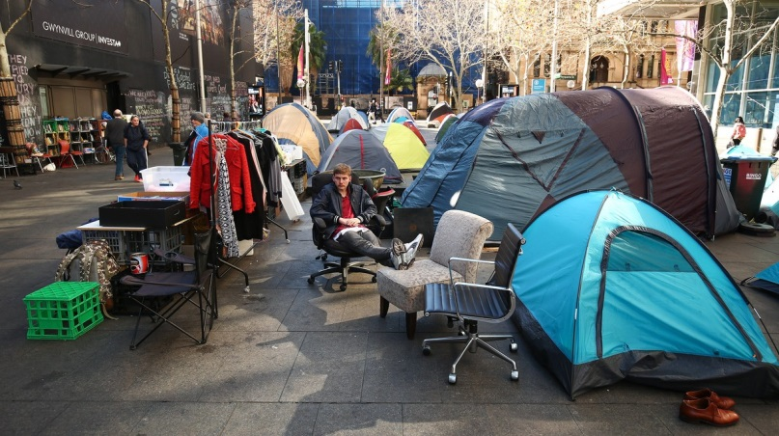  
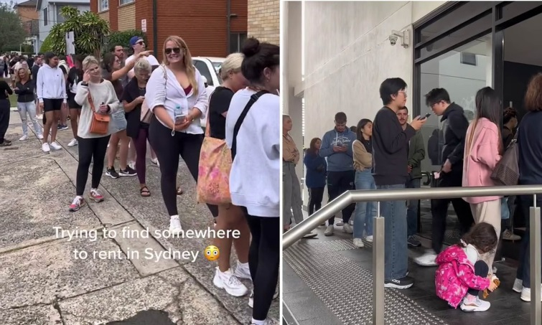

|  |  |
| --- | --- |
| **Age** | **20-50** |
| **Occupation** | Teacher, nurse, barista, office worker, etc. (middle-income professions) Retail worker, cleaner, security guard, etc. (low-income professions) |
| **Marital** **status** | This age group covers all types of people: married, unmarried, who have children, old people, disabled people, orphans working for themselves, etc. |
| **Location** | Sydney, Melbourne, Brisbane, Adelaide, Perth, Hobart, Darwin, Canberra.(Nearer to all these cities, as these crises are majorly going on in these cities. Connectivity and transportation should not become a problem.) |

# Gantt Chart

# Reference List

1. Hackworth, J., & Johnson, M. P. (2018). The mental health consequences of housing insecurity: A review of the evidence. *Social Science & Medicine*, 210, 251-261. <https://www.ncbi.nlm.nih.gov/pmc/articles/PMC9033895/>
2. Lawson, D. (2017). The financialization of housing and the erosion of affordability: A global perspective. *International Journal of Housing Policy*, 17(2), 133-154. <https://www.tandfonline.com/doi/full/10.1080/12265934.2019.1687320>
3. Dalton, T., & Vasquez, A. I. (2020). The effects of affordable housing on mental health: A systematic review. *Journal of Urban Health*, 97(1), 182-193. <https://pubmed.ncbi.nlm.nih.gov/31326010/>
4. Adair, K., Baum, F., & Zabel, R. (2019). The impact of rising housing costs on social cohesion: Evidence from Australia. *Urban Studies*, 56(7), 1572-1592. <https://www.wsj.com/articles/australian-home-prices-defy-rate-hikes-tightening-grip-915abf53>